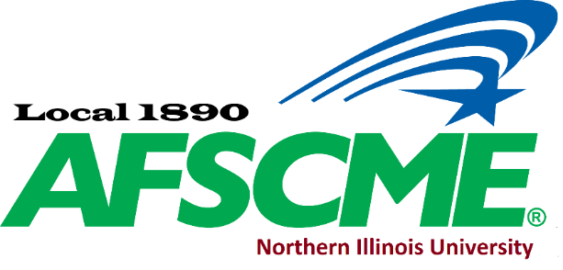

|  |  |  |  |  |
| --- | --- | --- | --- | --- |
| **Office** | **Name** | **Work email** | **Phone** | **Building/office** |
| President | Rave Meyer | [raveafscme1890@gmail.com](mailto:raveafscme1890@gmail.com) | 753-6563 | Montgomery Hall 325 |
| Vice President | Nicole Adams | [nadams@niu.edu](mailto:nadams@niu.edu) | 753-0372 | Psych 400 |
| Secretary Treasurer | Daksha Patel | [ddnk91@gmail.com](mailto:ddnk91@gmail.com) | 753-1450 | Music Building 132 |
| Recording Secretary | Lesly Schoo | [LSchoo@niu.edu](mailto:LSchoo@niu.edu) | 753-7606 | Music Building 128 |
| Member at Large | Amanda Smothers | [Amanda.smothers@niu.edu](mailto:Amanda.smothers@niu.edu) | 753-5803 | Academic Center 116 |
| Member at Large | Suzanne Hogan | [shogan@niu.edu](mailto:shogan@niu.edu) | 753-7959 | Zulauf 3rd floor |
| Member at Large | Krystyna Kamka | [krystynakamka@gmail.com](mailto:krystynakamka@gmail.com) | 753-1531 | Ctr for Latino & Latin Amer St |
| PEOPLE Chair |  |  |  |  |
| Member Chair | Sara Finnigan | [Sfinnigan@niu.edu](mailto:Sfinnigan@niu.edu) | 753-1272 | Lowden Hall |
| Chief Steward | Heidi Carlson | [HCarlson@niu.edu](mailto:HCarlson@niu.edu) | 753-2161 | HSC |

**Please sign up to the Facebook page for communications at AFSCME Local 1890 NIU**

**\*\*\*** **If you have any questions about your rights in general, please feel free to message the Administrators via Facebook, or contact your Staff Representative Rick Surber** [**RSurber@AFSCME31.org**](mailto:RSurber@AFSCME31.org) **or** [**afscmelocal1890niu@outlook.com**](mailto:afscmelocal1890niu@outlook.com)**. \*\*\***

**Stewards**

|  |  |  |  |  |
| --- | --- | --- | --- | --- |
| **Office** | **Name** | **Work email** | **Phone** | **Building/office** |
| Steward | Tom Kapraun | [TKapraun@niu.edu](mailto:TKapraun@niu.edu) | 753-6778 | DuSable Hall 359B |
| Steward | Angie Gasero | [adybas@niu.edu](mailto:adybas@niu.edu) | 753-0612 | Reavis 216A |
| Steward | Rave Meyer | [raveafscme1890@gmail.com](mailto::raveafscme1890@gmail.com) | 753-1814 | Montgomery Hall 325 |
| Steward | Jake DaSilva | [jdasilva@niu.edu](mailto:jdasilva@niu.edu) | 614-736-9020 |  |
| Chief Steward | Heidi Carlson | [hcarlson@niu.edu](mailto:hcarlson@niu.edu) | 901-2441 | HSC |
| Steward | Kristin Sherman | [Ksherman2@niu.edu](mailto:Ksherman2@niu.edu) | 753-1450 | Music Building 132 |
| Steward | Beth Reiter | [BReiter@niu.edu](mailto:BReiter@niu.edu) | 312-720-2835 | Faraday Hall 362 |
| Steward | Jen Schroll | [Jschroll@niu.edu](mailto:Jschroll@niu.edu) | 753-0566 | Watson 320 |
| Steward | Lesly Schoo | [LSchoo@niu.edu](mailto:LSchoo@niu.edu) | 753-0618 | Swen Parson 190 |