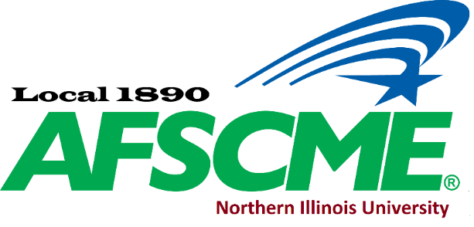

|  |  |  |  |  |
| --- | --- | --- | --- | --- |
| **Office** | **Name** | **Work email** | **Phone** | **Building/office** |
| President | Rave Meyer | [raveafscme1890@gmail.com](mailto:raveafscme1890@gmail.com) | 753-6563 | Montgomery Hall 325 |
| Vice President | Sarah Lindell | [slindell@niu.edu](mailto:slindell@niu.edu) | [753-9526](tel:815-753-9526) | Williston Hall |
| Secretary Treasurer | Daksha Patel | [ddnk91@gmail.com](mailto:ddnk91@gmail.com) | 753-1450 | Music Building 132 |
| Recording Secretary | Lesly Schoo | [LSchoo@niu.edu](mailto:LSchoo@niu.edu) | 753-7606 | Music Building 128 |
| Member at Large | Jacklyn Egolf | [jegolf@niu.edu](mailto:jegolf@niu.edu) | 753-8392 | Founders Memorial Library |
| Member at Large | Bryan Lutes | [Blutes@niu.edu](mailto:Blutes@niu.edu) | 753-1626 | Univ Adv & NIU Foundation |
| Member at Large | Krystyna Kamka | [krystynakamka@gmail.com](mailto:krystynakamka@gmail.com) | 753-1531 | Ctr for Latino & Latin Amer St |
| PEOPLE Chair |  |  |  |  |
| Member Chair | Sara Finnigan | [Sfinnigan@niu.edu](mailto:Sfinnigan@niu.edu) | 753-1272 | Lowden Hall |
| Chief Steward | Heidi Carlson | [HCarlson@niu.edu](mailto:HCarlson@niu.edu) | 753-2161 | HSC |

**Please sign up to the Facebook page for communications at AFSCME Local 1890 NIU**

**\*\*\*** **If you have any questions about your rights in general, please feel free to message the Administrators via Facebook, or contact your Staff Representative Rick Surber** [**RSurber@AFSCME31.org**](mailto:RSurber@AFSCME31.org) **or** [**afscmelocal1890niu@outlook.com**](mailto:afscmelocal1890niu@outlook.com)**. \*\*\***

**Stewards**

|  |  |  |  |  |
| --- | --- | --- | --- | --- |
| **Office** | **Name** | **Work email** | **Phone** | **Building/office** |
| Steward | Tom Kapraun | [TKapraun@niu.edu](mailto:TKapraun@niu.edu) | 753-6778 | DuSable Hall 359B |
| Steward | Angie Gasero | [adybas@niu.edu](mailto:adybas@niu.edu) | 981-9974 | 711 N First St |
| Steward | Rave Meyer | [raveafscme1890@gmail.com](mailto::raveafscme1890@gmail.com) | 753-6563 | Montgomery Hall 325 |
| Steward | Debbie Williams | [DWilliams16@niu.edu](mailto:DWilliams16@niu.edu) | 753-0425 | Williston 408 |
| Chief Steward | Heidi Carlson | [hcarlson@niu.edu](mailto:hcarlson@niu.edu) | 901-2441 | HSC |
| Steward | Sarah Lindell | [slindell@niu.edu](mailto:slindell@niu.edu) | 753-9526 | Williston Hall 406 |
| Steward | Kristin Sherman | [Ksherman2@niu.edu](mailto:Ksherman2@niu.edu) | 753-1450 | Music Building 132 |
| Steward | Beth Reiter | [BReiter@niu.edu](mailto:BReiter@niu.edu) | 312-720-2835 | Faraday Hall 362 |
| Steward |  |  |  |  |